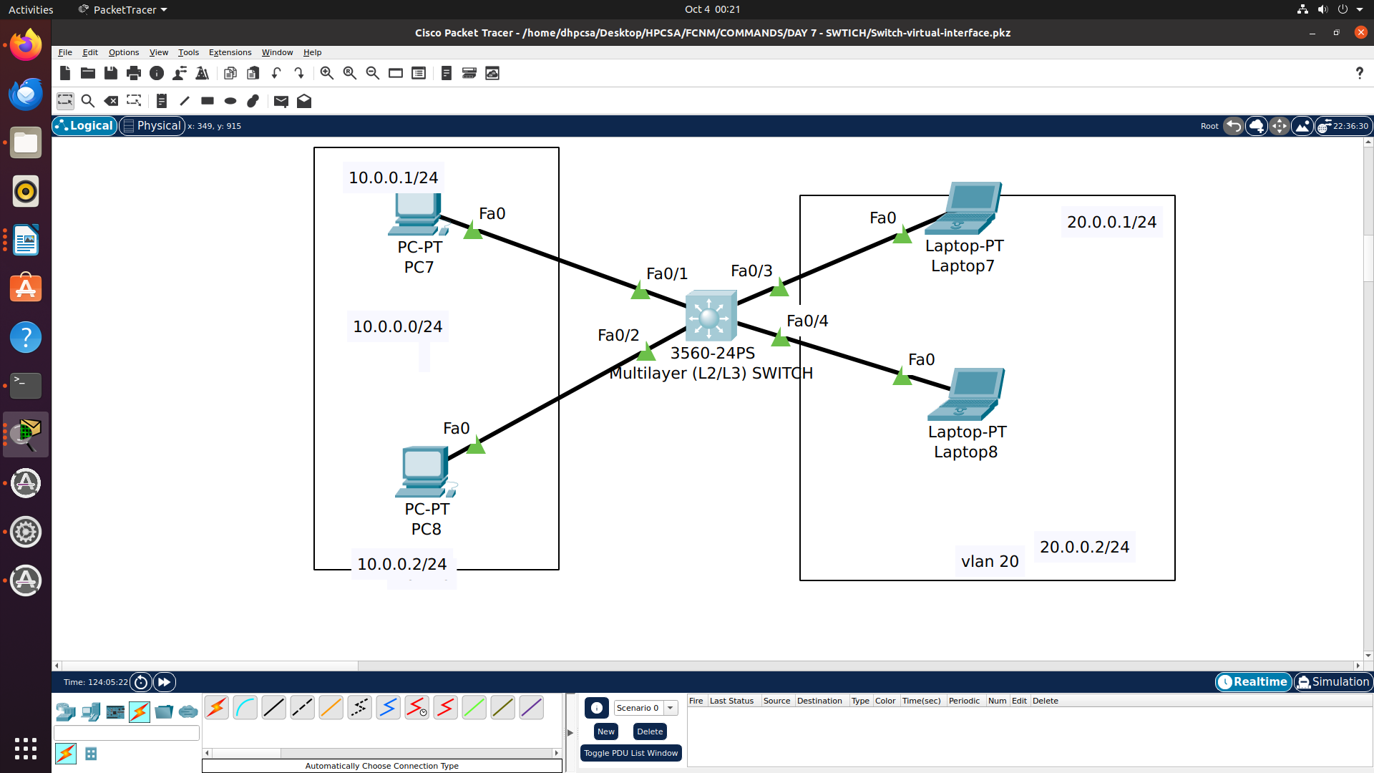

Switch Virtual Interface

SW1(config)#int range fastEthernet 0/1-2
SW1(config-if-range)#switchport access vlan 10
SW1(config-if-range)#switchport mode access

SW1(config)#int range fastEthernet 0/3-4
SW1(config-if-range)#switchport access vlan 20
SW1(config-if-range)#switchport mode access

To enable routing module on multi-layer switch
SW1(config)#ip routing

SW1#show ip interface brief

FastEthernet0/3 unassigned YES unset up up
FastEthernet0/4 unassigned YES unset up up
FastEthernet0/5 unassigned YES unset down down
FastEthernet0/6 unassigned YES unset down down
FastEthernet0/7 unassigned YES unset down down
FastEthernet0/8 unassigned YES unset down down
FastEthernet0/9 unassigned YES unset down down
FastEthernet0/10 unassigned YES unset down down
FastEthernet0/11 unassigned YES unset down down
FastEthernet0/12 unassigned YES unset down down
FastEthernet0/13 unassigned YES unset down down
FastEthernet0/14 unassigned YES unset down down
FastEthernet0/15 unassigned YES unset down down
FastEthernet0/16 unassigned YES unset down down
FastEthernet0/17 unassigned YES unset down down
FastEthernet0/18 unassigned YES unset down down
FastEthernet0/19 unassigned YES unset down down
FastEthernet0/20 unassigned YES unset down down
FastEthernet0/21 unassigned YES unset down down
FastEthernet0/22 unassigned YES unset down down
FastEthernet0/23 unassigned YES unset down down
FastEthernet0/24 unassigned YES unset down down
GigabitEthernet0/1 unassigned YES unset down down
GigabitEthernet0/2 unassigned YES unset down down
Vlan1 unassigned YES unset administratively down down

create two more vlan (vlan 10 (virtual interface) & (vlan 20 (virtual interface)
SW1(config)#interface vlan 10
SW1(config-if)#
%LINK-5-CHANGED: Interface Vlan10, changed state to up

%LINEPROTO-5-UPDOWN: Line protocol on Interface Vlan10, changed state to up

SW1(config-if)#ip address 10.0.0.254 255.255.255.0
SW1(config-if)#exit

SW1(config)#int vlan 20
SW1(config-if)#
%LINK-5-CHANGED: Interface Vlan20, changed state to up

%LINEPROTO-5-UPDOWN: Line protocol on Interface Vlan20, changed state to up

SW1(config-if)#ip address 20.0.0.254 255.255.255.0
SW1(config-if)#no shutdown

